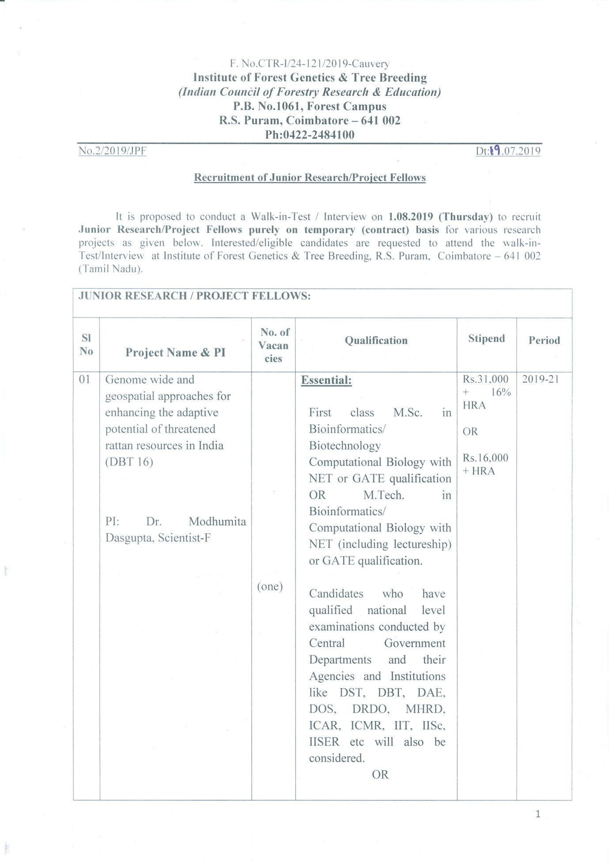

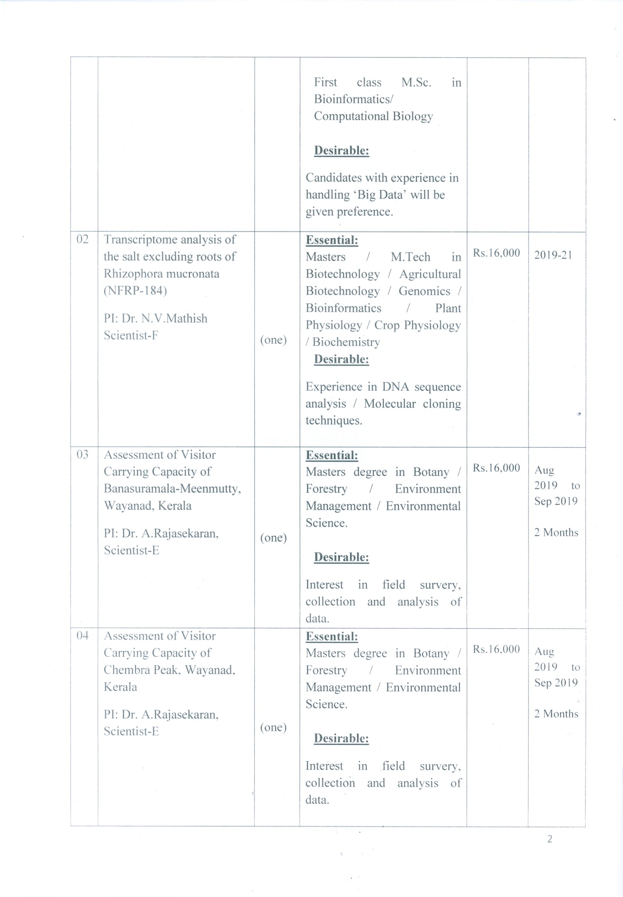

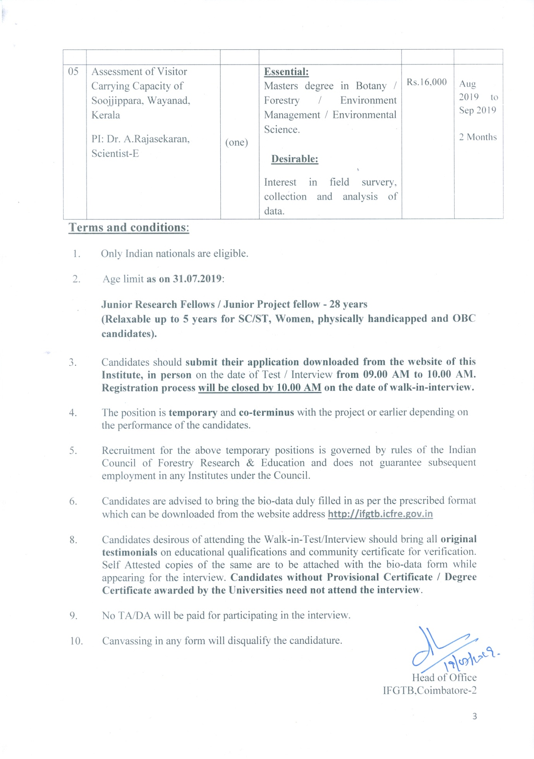

**Institute of Forest Genetics & Tree Breeding**

*(Indian Council of Forestry Research & Education)*

(An autonomous body of the Ministry of Environment & Forests, Govt. of India)

P.B. No.1061, Forest Campus

R.S. Puram, Coimbatore – 641 002

Affix Passport size Photograph

------

Application Proforma

1. Advertisement No : ­­­­­­­­­­­­­­­­­­­ **02/2019/JPF**

2. Name of the Position :

3. Name of the Project :

4. Name in Capital Letter :

5. Father’s Name :

6. Date of Birth :

7. Aadhaar No. :

8. Age as on **31.07.2019** :

9. Sex/Marital Status (√) :

Married

F

Unmarried

M

10. Whether belongs to : SC / ST / OBC / PH

11. Present and Permanent Address with

Telephone/cell No/Email. :

12. Educational Qualification

(attach self attested copies of testimonials) :

|  |  |  |  |  |  |  |
| --- | --- | --- | --- | --- | --- | --- |
| Qualification | Institution | University/Board | Year of Passing | Subject | Division/ % of Marks | Specialization |
| SSLC |  |  |  |  |  |  |
| HSC/+2 |  |  |  |  |  |  |
| B.Sc |  |  |  |  |  |  |
| M.SC |  |  |  |  |  |  |
| Ph.D |  |  |  |  |  |  |
| NET/DBT-BET/GATE score |  |  |  |  |  |  |
| Any other |  |  |  |  |  |  |

13. Whether receiving Scholarship/Fellowship

From any agency? If yes, indicate :

14. Are you under any contractual obligation to

Serve Central/State Govt/Any other public

Sector Undertaking or Autonomous body and

If so, give details(attach NoC if applicable) :

14. Previous research experience (in bullet points)

(Enclose copies of experience certificate)

15. Publications if any :

16. Any other relevant information :

(not more than 50 wards)

17. Language Proficiency :

18. Name & Address of two references :

(known for a minimum of two years)

**Declaration**

**I hereby declare that the above information is correct and to the best of my knowledge and belief, if I am found to have concealed/distorted any material information, my appointment shall be liable for termination without notice.**

**Place: Signature of Candidate**

**Date:**